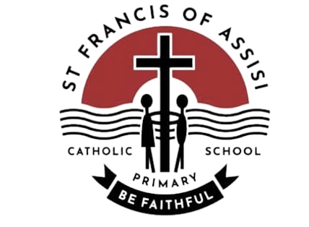

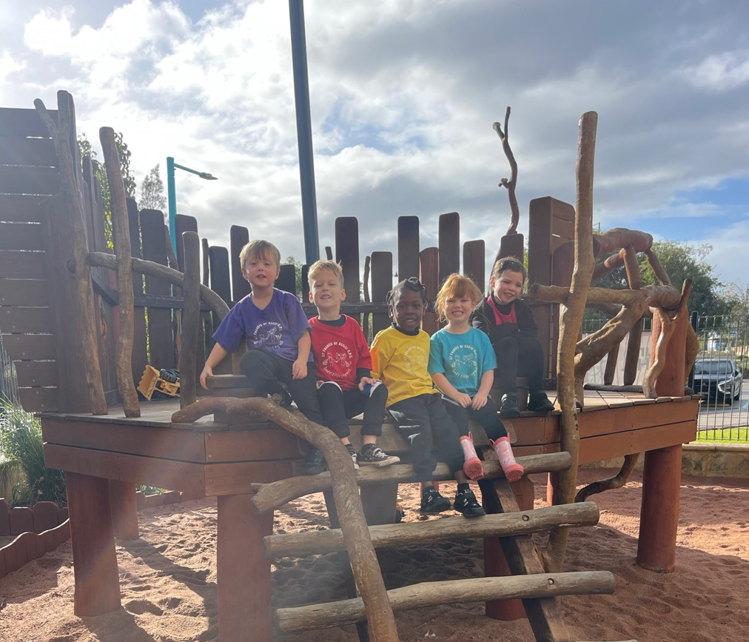

Pre-Kindy
SFOA

Welcome to Pre-Kindy at St Francis of Assis CPS

Our Pre-Kindy program is designed to help your child prepare for Kindergarten by providing them with a safe and nurturing environment where they can learn and grow. We offer a variety of fun and engaging activities that are designed to help your child develop a love of learning and build a strong foundation for their future schooling.

Who can attend?
Children are eligible to start the Pre-Kindy programme once they have turned three. This can be any time of the year and your placed can be secured through completing an enrolment form and a $50 non-refundable deposit.
Our maximum class size is 20 children with one teacher and teacher assistant.

Session Times
Our Pre-Kindy classes will take place on a Thursday from 8:30-2:30 in the Kindy B classroom.

Fees
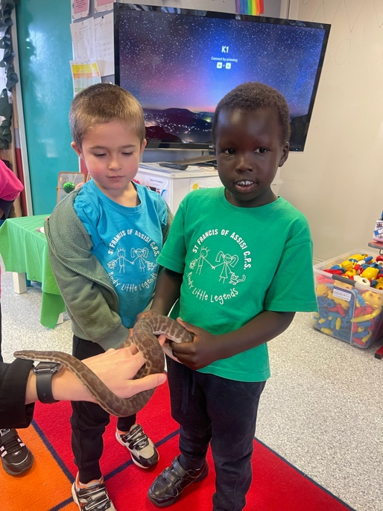
$50- 1 Full Day Session per week on a Thursday.

Please note the fee is only payable once your child has turned three and commences Pre-Kindy.
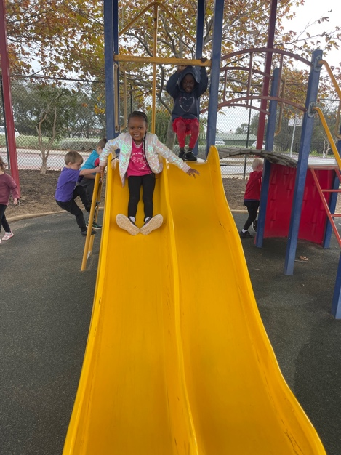
Our Pre-Kindy program is staffed by qualified Early Childhood Teachers and accredited Education Assistants. Our staff have had numerous years of experience in the early years are committed to providing a high-quality learning experience for all children. Our staff embrace the joy that young children bring to the daily life of a classroom. We encourage families to be actively involved in their child’s learning and welcome their input, feedback, and suggestions.

Early years Curriculum
Our program is designed to provide a safe, nurturing, and stimulating environment that encourages children to learn and grow.
The Pre-Kindy program is guided and devised by the principles of The Early Years Learning Framework (EYLF) and the National Quality Standards (NQS)

The EYLF is based on the following five learning outcomes:
- Children have a strong sense of identity.
- Children are connected with and contribute to their world.
- Children have a strong sense of wellbeing.
- Children are confident and involved learners.
- Children are effective communicators.

We aim to achieve these outcomes by providing a play-based learning environment that is child-centred and responsive to children’s interests, needs and abilities. Our program is designed to foster children’s social, emotional, cognitive, and physical development through a range of experiences.

The National Quality Standards (NQS)
The NQS is a set of standards that all early childhood educators must met. Our Pre-Kindy program is committed to meeting and exceeding the NQS in all areas. This includes educational program and practice, children’s health and safety, physical environment, staffing arrangements, relationships with children and collaborative partnership with families.

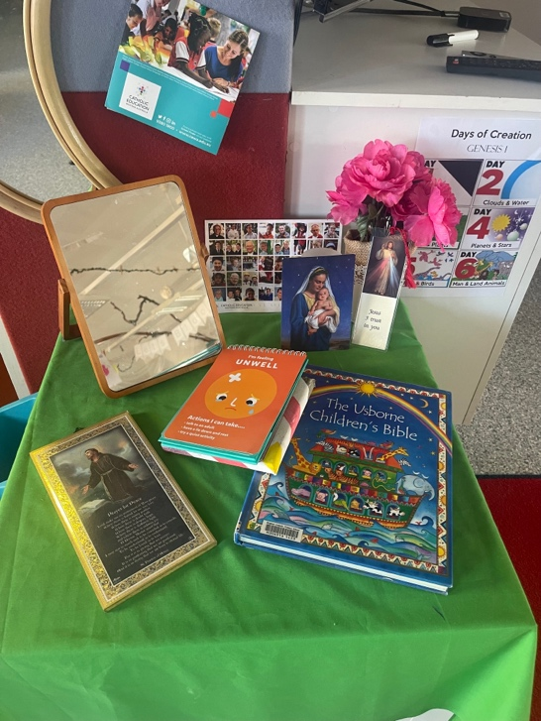
Religious Education
Religious Education at SFOA is integrated into our daily activities. The children will experience a growing sense of belonging and community. and the world around us. We link the everyday experiences with a developing understanding of God and God’s love for them. Children are also encouraged to participate in prayerful moments throughout the day through song, movement and prayer.

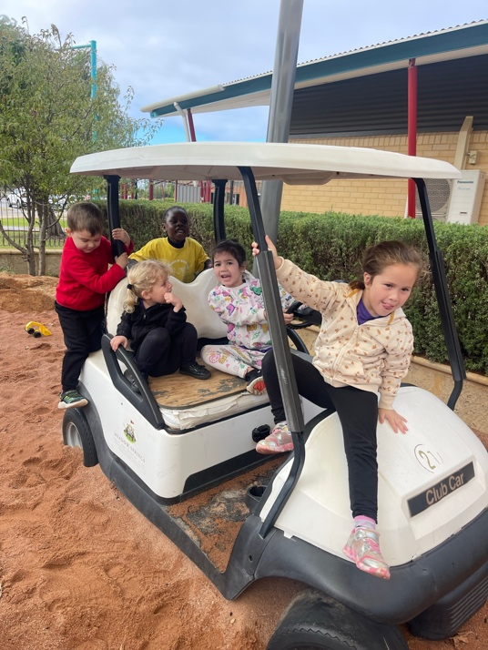
Procedures for Arrival/Pick up.

Arrival
The Pre-Kindy day begins at 8:30. We have an open-door policy that allows for parents to drop and go or stay and play between 8:30-8:50. At 8:50 a bell will ring, and the children will come to the mat for a welcome song and story book. This allows to help children who are slightly anxious. We will always contact you if needed and communicate throughout the day if the need arises.

Pick Up-Pick up time is at 2:30 from the Kindy B classroom. We are only able to dismiss your child to authorise adults, over the age of 18. If an adult other than yourself will regularly pick up your child, we will need to be provided with a note with the authority for this to occur. If a change occurs on the day, please let the Pre-Kindy staff know on the relevant day so this can be recorded.

What to bring to Pre-Kindy
- A LARGE backpack big enough to carry:
  - A few labelled spare change of clothes in case of accidents or water play (including underwear and socks)
  - A labelled sun-smart hat with a wide brim.
  - A labelled water bottle with only water.
  - A ‘crunch and sip’ container that has only fruit or veg in a separate clearly labelled container.
  - A healthy recess (such as cut up fruit, cheese and crackers) in an easily opened container.
  - A healthy lunch (sandwich, yoghurt, fruit etc. We are an allergy aware school so NUTs please, including nut spreads i.e., Nutella.
  - Please leave cakes, lollies, sweet treats and biscuits for home time.

Dress Code

Please send children to Pre-Kindy in play clothes. This includes easy to move, pull up and down and comfortable to wear. Messy play is unavoidable in Pre-Kindy so please avoid ‘best or precious clothes.’
Some tips for clothing choices:
  - Avoid belts and buckles.
  - Avoid long skirts and dresses.
  - Shoes easy to put on and off- VELCRO only please.
  - Apply sunscreen before school.
  - Red Pre-Kindy t-shirts will be provided.
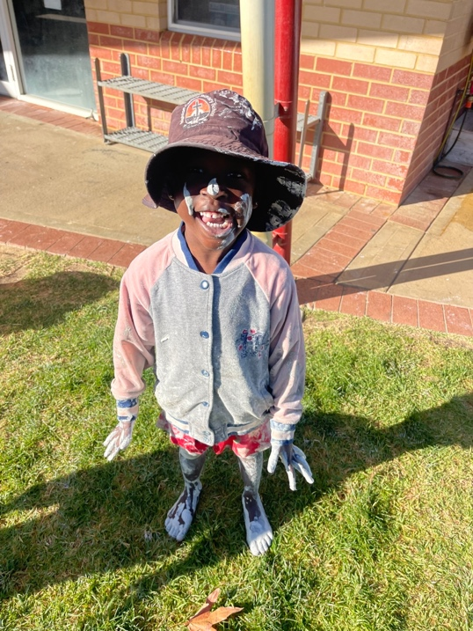

Toilet Training
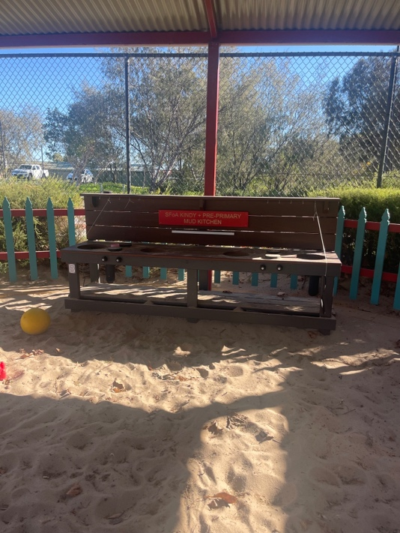
It is preferred that children attending Pre-Kindy are toilet trained, however we understand this is not always achievable. We expect and are prepared for accidents that may occur. If your child is still in nappies, pull ups are the preferred nappy of choice and please notify the classroom teacher.

Personal Toys and Items
Please keep all personal toys and items at home to avoid things being lost or ruined at school.

Preparing for Pre-Kindy
Preparing for pre-kindergarten can help your child feel more comfortable and confident as they transition to a new learning environment. Here are some tips to help you prepare your child for Pre-Kindy.

- Talk to your child about what to expect: Explain what Pre-Kindy is about and what they will be doing there. Talk to them about the daily routine, the activities they will be doing and the new friends they will make.
- Practice self-help skills: Encourage your child to practice self-help skills such as dressing themselves, using the bathroom independently, and washing their hands.

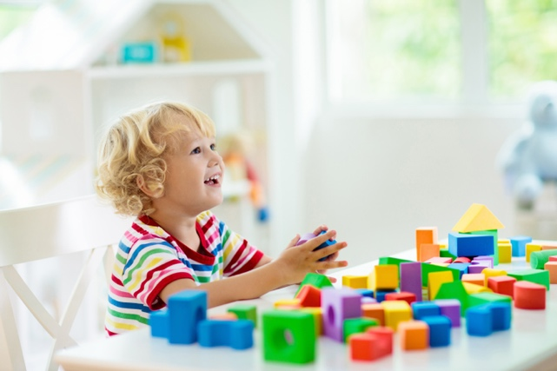
Communication
Our first concern is the happiest and well-being of your child. We have an open-door communication policy so please let us know if anything that could be causing upset, stressed or unhappy. Please email the teacher if you have a particular concern following the template firstname.surname@cewa.edu.au.

In Pre-Kindy, we use the app Seesaw as a communication tool for parents. We will use this app to keep you updated on how your child is going as well as the activities they do throughout the day.

Health
If your child is sick, please do not send them to school. If they are too unwell, please notify the school or office via phone or email sent to school by 9am.

Allergies and Asthma
If your child has an allergy or asthma, you will be required to provide the school with a medical action plan (signed by a doctor) and relevant medication. Please see staff if your child needs to have a form completed and we will advise you about what is required.

We look forward to working with you and your child to create a positive and engaging learning experience that prepares them for a lifetime of learning. If you have any questions or would like to learn more about our program, please do not hesitate to contact us.

